Arthritis Foundation
Self-Directed enhanced Kit

Table of Contents
Introduction to Walk With Ease Self Directed….Page 2
Ready – Set – Go! Quick Overview………….….Page 4
Frequently Asked Questions (FAQs)…………….Page 5
Weekly Engagement Email Series…………........Page 9
Guidebook Distribution………………………........Page 17
Marketing…………………………………………….Page 19
Additional Resources………………………………Page 21
Appendix COVID-19/Safety Resources………..Page 22

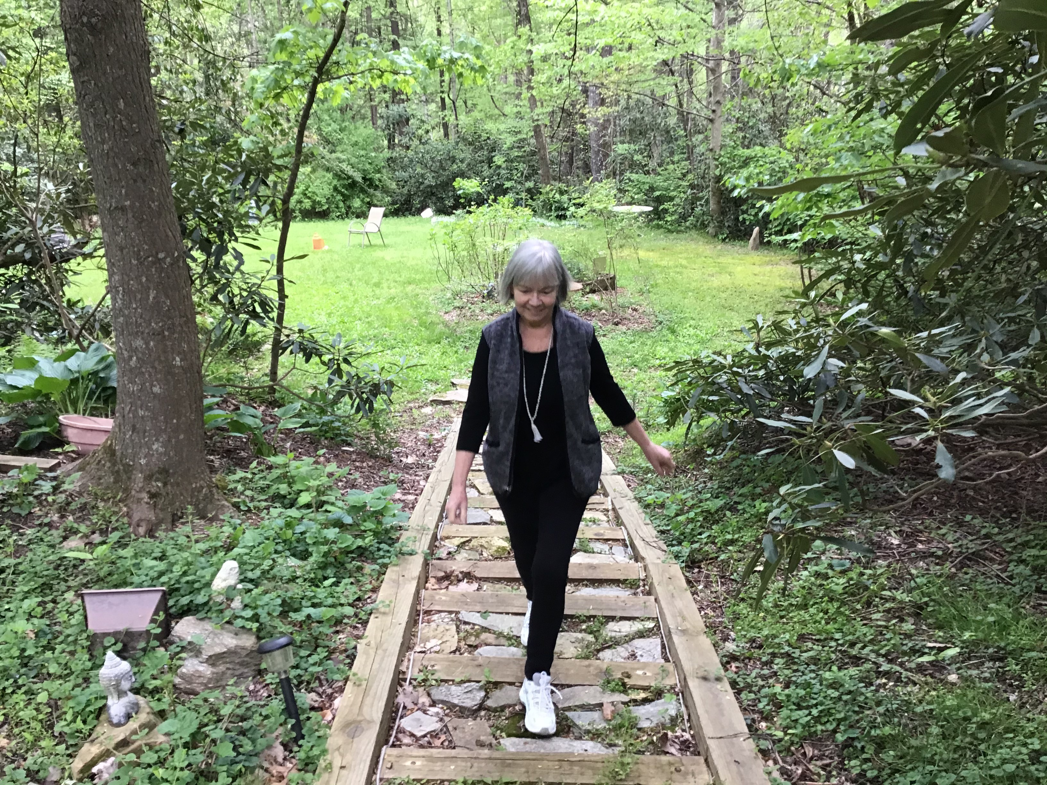
Walk With Ease- Self-Directed Enhanced Kit
This kit will help you lead a Walk With Ease Self-Directed Enhanced program. The Arthritis Foundation’s six-week Walk With Ease program is proven to reduce the pain of arthritis and improve overall health. It can teach program participants how to safely make physical activity part of their everyday life. The program includes a guidebook and a walking schedule to get participants safely moving toward better health. Plus, there are tools to help participants stay motivated and overcome obstacles.
With the Walk With Ease Self-Directed Enhanced Program, a group of participants will begin and finish the program at the same time. The program leader will share regular reminders and updates about the program and opportunities for interactions through email, social media, message boards, text, phone/video calls. You may innovate with your communication delivery, but do not add, change, or delete any components of the program.
Walk With Ease is proven to:
- Reduce the pain and discomfort of arthritis
- Increase balance, strength and walking pace
- Build confidence in your ability to be physically active
- Improve overall health
You can use this kit to coordinate a Walk With Ease Self-Directed Enhanced Program for your co-workers, family, friends, and neighbors. The kit and program include everything you need to develop a walking plan, keep your crew motivated, share ways to manage pain and provide exercise safety tips.

Arthritis Foundation
REady!
Set!
Go!
- Get ready!
  - Read the program FAQs in this kit and review leader resources online at www.arthritis.org/WWE
  - Recruit your crew
    - Reach out to your co-workers, family, friends, neighbors, and other community members to join the fun. Use the template flyers to share via email and through social media posts.
    - Use organizing apps like Sign-Up Genius to make registration easy.
  - Order the Walk With Ease guidebooks (or the Spanish version Camine Con Gusto) at www.AFStore.org. The participant book is $11.95 + shipping. (Discounts are available.)
    - A Kindle e-book option is available via Amazon (www.amazon.com).
    - A Kindle device is not required, just the free Kindle app.

- Get set!
  - Select your dates – Choose a starting and ending date for the six-week program. Participants pledge to walk at least three times per week.
  - If needed, pick up a sturdy pair of walking shoes, quality socks and comfortable workout clothes.
  - Optional – Choose sites for optional group walks.
- Go!
  - Get walking!
  - Send out your first communication – email, group text or social media post.
  - Keep in touch – Share an instructional message weekly.
  - Make it fun! Video conferencing can provide opportunities to connect and share updates. Share photos and videos of your walks and post workout smiles!

Walk With Ease Frequently Asked Questions (FAQs)
What is the Walk With Ease Program?
The Arthritis Foundation’s Walk With Ease Program is a community-based physical activity and self-management education program. While walking is the central activity, Walk With Ease is a multi-component program that also includes health education, stretching and strengthening exercises, and motivational strategies. There are three program formats:
- Group – All 18 sessions are led by an in-person, Arthritis Foundation-certified leader.
- Self-Directed – An individual uses the Walk With Ease Guidebook to complete the six-week program on his/her own.
- Self-Directed Enhanced – A group of individuals begin and end the six-week program at the same time. A designated leader coordinates communication to ensure participants are organized and motivated to complete program. Detailed toolkit.
What are the program goals and objectives?
The overall goals of the Walk With Ease Program are:
- To promote education about physical activity for adults with arthritis.
- To promote education about arthritis self-management and walking safely and comfortably.
- To encourage participants to continue their walking program and explore other exercise and self-management programs that deliver proven benefits for adults with arthritis.
During the six-week program, participants will:
- Understand the basics about arthritis and the relationship between arthritis, exercise, and easing pain.
- Exercise safely and comfortably.
- Use methods to make walking fun.
- Make a personal walking plan with realistic goals for improved fitness.
- Learn tips and resources to help them overcome barriers and continue to be physically active.
- Learn about other programs and resources that can help them maintain their walking and try other physical activity.
Who should participate in the program?
Walk With Ease is for adults with arthritis who want to be more physically active. The program is also for adults without arthritis, particularly those with diabetes, heart disease or other chronic conditions who wish to be more physically active. The only requirement is the ability to stand for at least 10 minutes without increased pain.
What are the essential program parts and activities?
Walking
Participants walk at their own pace for 10 to 35 minutes.
Health education information
All participants receive the Walk With Ease guidebook with information on how to get ready to walk, begin walking and stay motivated to continue walking.
The guidebook also provides basic information on arthritis, managing pain and stiffness, proper clothing and equipment, self-monitoring for physical problems, safety precautions and how to anticipate and overcome barriers to being physically active.
Stretching and Strengthening Exercises
Participants are encouraged to do stretching exercises before they walk and strengthening exercises twice a week. The Walk With Ease guidebook includes directions for stretching and strengthening exercises. Individuals can also access videos of these exercises on the Arthritis Foundation’s Walk With Ease website.
Motivational Tips and Tools
The Walk With Ease guidebook includes self-tests, a six-week contract and walking diary forms. It helps participants identify their needs and interests, set goals and rewards and track progress. Each guidebook chapter also contains motivational tips. An online support component is also available to participants. The Arthritis Foundation’s Walk With Ease website provides many online tools. Participants can complete their program contract, set starting and ending points, take self-tests and compare scores from other tests. Participants can also log activities, review their progress, and update their goals via the online contract.
What is the length/ timeframe of the program?
Walk With Ease is a six-week program. The Group program has three sessions per week for six weeks. Participants completing the Self-Directed and Self-Directed Enhanced formats are encouraged to walk at least three times per week.

Arthritis Foundation
Engagement Series
Email Engagement Series

The following communication materials are designed to be distributed weekly to program participants. The series may be updated to include local information. However, the program-specific information should not be changed. Please note, leaders may also post these messages on a discussion board or on social media. Special thanks to Oregon State University Extension Service for creating the following series.

An optional, complementary video series was developed to accompany the email series. The videos aim to provide context and clarification about the program and components. Additionally, the videos may be more engaging for visual learners and those with difficulty digesting the text. The creators took care to showcase a variety of people engaging in the program to inspire and motivate participants. As noted above the videos may be shared a part of the regular program communication. The videos may be shared via email, social media, or discussion board. Organizations may include local, organization-specific information to accompany the videos. The videos may not be edited or abridged without our express written permission. If you have a comment, change request or suggestion to improve the email and video series, please contact Nick Turkas, Arthritis Foundation – nturkas@arthritis.org. Special thanks to Oregon State University Extension, South Dokata State University Extension, and University of Delaware Cooperative Extension for creating the series.

WELCOME EMAIL:

Thanks for joining Walk With Ease! Taking part in the Walk With Ease (WWE) fitness program helps reduce your pain and improve your health. This proven program provides techniques to build and maintain a successful walking program and was created by experts at the Arthritis Foundation.

Useful Walk With Ease resources are available online:
- The Arthritis Foundation website contains a wealth of online tools and resources
- Vim The Arthritis Foundation’s pain management provides a platform to set goals and share successes.
- Bad hip? Arthritis in your knee? Check out Your Exercise Solution for personalized exercise modifications just for you.

We’re so glad you’ve joined this program! Please let us know if you have any questions or concerns.

Your Name Here

WEEK ONE: FOCUS ON WHY WALK WITH EASE/INTRODUCTION TO PROGRAM
*Attachments: Be sure to include information about arthritis (lecturette posters)
Your Walk With Ease program begins TODAY! Welcome! We’ll send you weekly updates, resources, information and “lecturettes.” These emails are designed to support your personal efforts and ensure you’re staying on-track with the Walk With Ease guidebook and are progressing in your knowledge and physical activity.

WHY WALKING?
- Walking is simple, inexpensive, and safe for all ages and abilities.
- It’s flexible — walk on your own, in a group, with a friend or a pet.
- It’s easy to track.
- Every minute of walking counts!
- There are many health benefits of walking.

DID YOU KNOW… PHYSICAL ACTIVITY IS THE NATURAL PAIN RELIEVER?
- Walking is one of the safest forms of physical activity to assist in pain management for those who have arthritis and other chronic health conditions.
- Walking reduces stiffness caused by many forms of arthritis while having a relatively low impact on joints.
- Walk With Ease is an evidenced-based program supported by the Arthritis Foundation and recognized by the Centers for Disease Control and Prevention.
HOMEWORK: GET READY TO GET MOVING!
- If you have it, read Chapter One of your Walk With Ease guidebook.
- Start thinking about where, when and who you’ll be walking with.
- Start planning now if you need any gear (shoes, socks, water bottle, pedometer, or step tracking app).
- Watch the Walk With Ease Week 1 video.
- Optional: Join the Live! Yes! Arthritis Network and find others in your community and online committed to living their best life.
So glad you’ve joined this program!
Let us know if you have any questions,
Your Name Here

WEEK TWO: FOCUS ON 5-STEP WALKING PATTERN & BOOK
*Be sure to include attachments: 5 Step Walking Pattern; Shoes, Socks & Clothes checklist; and Pick the Right Surface poster.
Hopefully, you now have your Walk With Ease guidebook and have started reading. The book is an EXCELLENT resource designed specifically for adults with arthritis or other chronic conditions. (It’s also generally useful if you’re new to physical activity.)

WHAT TO DO & READ THIS WEEK:
- Take the Starting Point Self-Test on pages 14-15
- If you have arthritis, be sure to read Chapter 2. There is additional information from the Arthritis Foundation on their website.
- Watch Walk With Ease Week 2 video.
- Look at Chapter 3 and the attached resources to further assist you!

THE 5-STEP WALKING PATTERN:
- Let’s skip ahead in your book to learn a key Walk With Ease strategy — the 5-step walking pattern (pages 100-104). This is fundamental to the program.
- Warm-Up: Start your walks with a slower pace for 3-5 minutes to warm up.
- Gentle Stretching: Take time to stretch (find instructions starting on page 150)
- Walk: Set a target/goal for each walk (can be time-based or distance-based)
- Cool-down: Once you’ve hit your target, slow your pace for 3-5 minutes to recover.
- Stretch again: Take the time to do this! Repeat beginning stretches and hold longer (30-45 seconds)

Give it a try this week! Make the 5-step walking pattern a habit so that warm-ups, cool-downs and stretching don’t get lost. Taking the time to invest in your well-being through proper walking strategies will give you greater success with less pain.
Grab your shoes and head out for a walk!

Your Name Here

WEEK THREE: PERSONAL CONTRACT & TRACKING
If you’ve been reading your book, you may be a step ahead on this week’s email topic: goal setting. I know, you may want to delete this email right now because setting goals isn’t always the most enjoyable task. But you’ve read this far, so why not continue and track your activity. After all, if you don’t know where you’re headed, how will you know when you’ve arrived?
CREATE A CONTRACT & BEGIN TRACKING:
- Simple steps to create a contract/goal… (pages 60+ provides a blank contract and diary pages)
- Make a contract with yourself – write your goals down. Fill in the blanks in the contract in your book. (page 60)
- Keep Records. A calendar, a notepad or sticky note, a wearable activity tracking device or mobile app will work, if you’ll use it. (page 61)
- Use self-measurement tools to check your progress. Track what you care most about: Steps? Minutes? Heart rate? Energy level? Exertion level? Breathing? It’s your choice.
- Check your plan every week. Jot down a few notes at the end of each week. Rate how you’re feeling, your walking progress and fitness test results. You can revise goals or plans, if needed.
- Decide how to reward yourself for sticking to it. Think simple, fun, and meaningful. Try not to reward yourself with unhealthy food. Bonus points for rewarding yourself with something that furthers your fitness goals (backpack, water bottle, new walking shoes, exercise DVD, etc.).

- Sample contract & tracking/diary worksheet are on pages 58 & 59.
- Think SMART goals (Specific, Measurable, Attainable, Relevant, Time-based)
- Apply the FITT principle to keep your goal specific:
  - Frequency; Intensity; Time; Type (see pages 44-47)

MIDPOINT FITNESS TEST:
This week marks the halfway point in your WWE program. Try measuring your fitness level with the options on pages 115-118:
- Measuring how far you can walk during a set period.
- Walk a specific distance and see how long it takes.
- Measure your heart rate after you’ve been walking for a certain amount of time.
You can perform the same measurement at the end of six weeks and see how you have improved!

This is your program. Customize it to meet your needs! Reach out if you have questions or concerns. And be sure to check out the Week 3 Walk With Ease Video and the many resources on the Arthritis Foundation website.

In health,
Your Name Here

WEEK FOUR: STRETCHING & STRENGTHENING EXERCISES
*Be sure to attach the stretching guide and strengthening guides and worksheets to this email (lecturette posters).
You are over half-way through the Walk With Ease program! Congratulations! You’ve likely been doing stretches with each of your walks, however, this week we’re providing a few more resources to make sure you’re stretching properly. In addition, it’s time to start strengthening exercises if you haven’t already. Read on and read the attachments to learn more.

STRETCHING:
The attached guide and Appendix B in your book will provide graphics and instructions. Here is the link to Walk With Ease Week 4 video that includes to videos of the stretches. Practice along while you watch!
- Straight leg calf stretch
- Hamstring stretch (seated version)
- Hip flexor/ Quadriceps stretch (seated version)
- Iliotibial Band stretch
- Bent leg calf stretch
- Front of calf/toe stretch

STRENGTHENING:
The attached guide and Appendix B in your book will provide graphics and instructions. Here is the link to watch videos of each exercise. Don’t just watch —
try it out!
- Back leg lift
- Heel & Toe Raises (seated version)
- Mini-Squats
- Quadriceps (seated version) (laying on your back version)

GENERAL TIPS:
- If you have trouble with balance, do the seated versions of these exercises instead of standing.
- Stretch gently/smoothly until you feel tension; then hold that position for 30 seconds on each side (no bouncing).
- Do not hold your breath, make sure you’re still breathing evenly.
- Always practice good body mechanics for walking & exercising:
  - Keep your head up.
  - Shoulders. Relaxed but not hunched
  - Lungs. Breathe deeply from your diaphragm
  - Stomach. Tighten your muscles a little
  - Arms. Swing naturally and easily, opposite to your legs
  - Hands. Don’t clench; relax them
  - Legs. Take regular, natural steps (not too long)

You’ve got this! Go for it this week and try improving your stretching time and adding strengthening exercises.

In health,
Your Name Here

WEEK FIVE: OVERCOMING & ANTICPATING BARRIERS
*Attachments: Coping with pain lecturette poster
Welcome to Week 5!
This week our focus is on the information and resources in Chapter 4 “Anticipating & Overcoming Barriers.” Let’s dive into the basics first…

TECHNIQUE FOR COPING WITH PAIN & DISCOMFORT
Walk With Ease promotes a 3-step problem strategy:
- Focus on the problem that is most on your mind.
- Ask yourself, “What might be causing this problem?”
- Try out different solutions.

Nothing fancy here… but you do need to focus on only ONE problem at a time. Then, use your book as a resource for finding and trying out various solutions.

RESOURCES IN YOUR BOOK
Page 34: Review the Exercise Dos and Don’ts from Chapter 2
Pages 71-78: You’ll find specific strategies such as using heat/cold, self-massage, changing self-talk, using a walking stick, etc.
Page 74: Use the 2-Hour pain rule as a guide
Pages 78-95: You’ll find common difficulties that set you back from accomplishing your goals and new ways to think about overcoming those difficulties.
Page 124: Common problems and what to do (calf cramp, sore shins/knees, etc.)
Problems will occur. You will have obstacles along your journey. Use these guides and resources to help you find solutions rather than give up. Review the Walk With Ease Week 5 video. Above all, always consult with your health care team to ensure a strategy is appropriate for you.

Keep moving!
Your Name Here

WEEK SIX: TOOLS & RESOURCES
It’s our final week of the Walk With Ease 6-week program. Thanks for hanging in there!

If you haven’t already, join the Arthritis Foundation Arthritis Network
- Watch the Walk With Ease Week 6 video.
- Go to https://liveyes.arthritis.org/ and create an account or login. You’ll find local support groups and an online forum to share your experiences, health tips and feedback about the program.
- Check out the Help page for individualized support including financial assistance, mental health support and help with access to care.
- Under “Exercise & Fitness Tools” – Click on Your Exercise Solution for tailored exercise modifications based specifically on YOUR arthritis and YOUR exercise preference. This tool has over 4,000 variations created by medical professionals including physical therapists.
- In the same section, you’ll find the online Walk With Ease tools! The online tool allows you to keep digital walking diaries and goals.
- In the Walk With Ease section – check out the stretching and strengthening exercise videos!
- Sign up for Vim, the Arthritis Foundation’s pain management and goal-setting app. Set goals and share your success.

There are too many other resources to list them here – check out the site and click around to see what can help you!

Next week, we’ll email you a link to our evaluation and some resources to help you keep going after WWE.

In health,
Your Name Here

POST PROGRAM: EVALUATION & WAYS TO KEEP GOING
Thank you for joining this program. We hope it has encouraged and supported you in your efforts to become more physically active with less pain.
OPTIONAL - PROGRAM EVALUATION:
We cannot offer these programs without collecting evaluation data. It is critical to our continuation of this program. Please consider taking a few minutes to complete the class evaluation at (If applicable, add survey info here)

WHAT’S NEXT?
Learn more about physical activity and steps you can take to ease arthritis pain:
- Arthritis Appropriate Evidence-Based Program
- Physical Activity for Arthritis (CDC)
- Chronic Disease Self-Management Program
Walk With Ease guidebook – Review Appendix.

Local organizations have resources as well:
Add local programs and community organizations including -
Local recreation center
Local senior center
Local community center
Local wellness center
Local health care organizations, hospitals
Local parks & recreation departments
Local community college
Find a program you’ll stick with long-term. Keep your WWE guidebook handy as a useful reference. Thanks again for joining us on this journey!

In health,
Your Name Here

Guidebook PurCHASING & Distribution METHODS

Arthritis Foundation
Guidebook Distribution
Where to buy books
The WWE guidebooks can be purchased at www.AFstore.org for $11.95 (discounts may be available from your sponsoring organization).

If you need to pay for books with a check or an invoice, contact Nick Turkas at nturkas@arthritis.org.
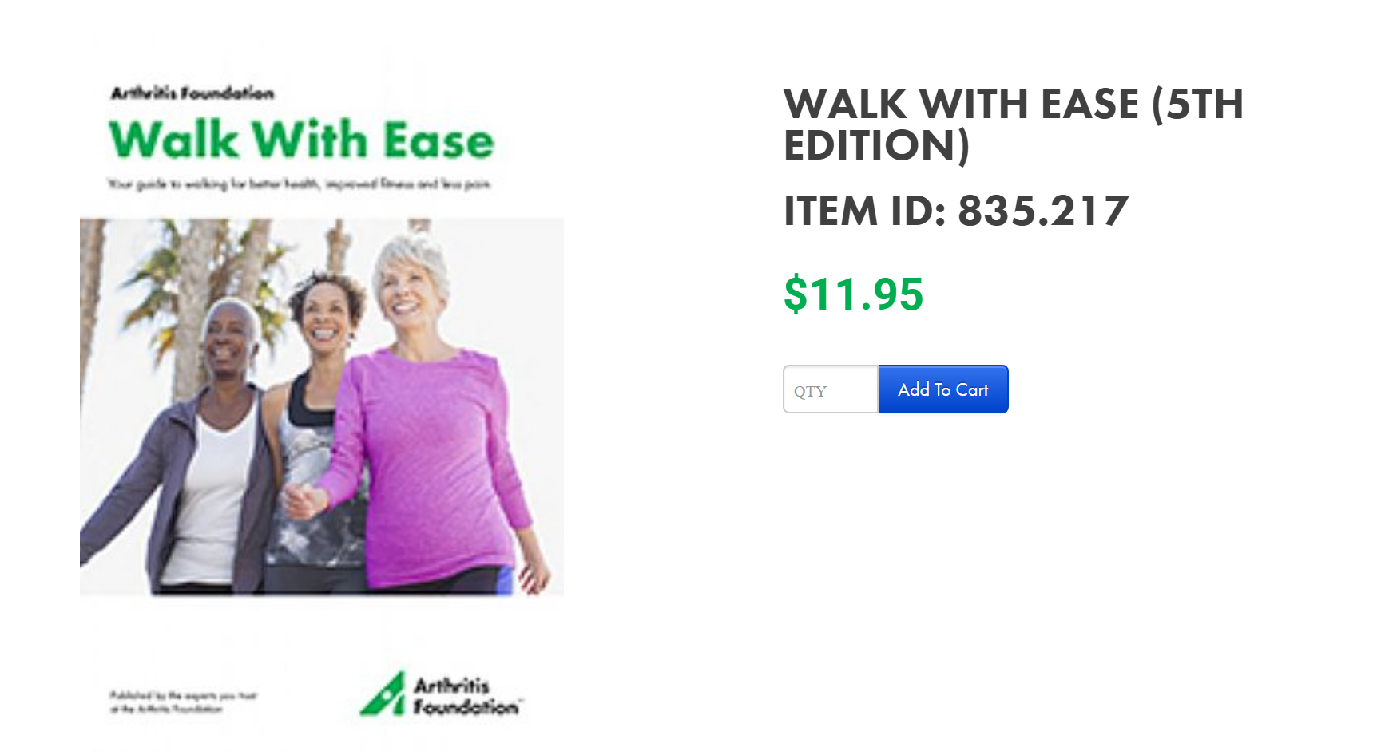
-OR-
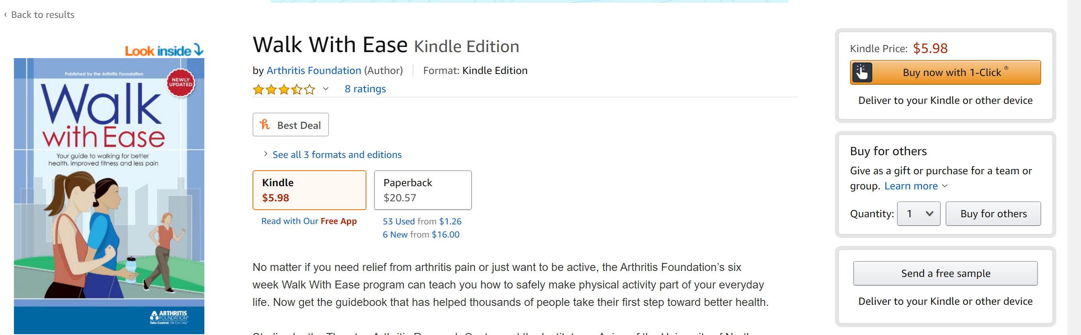

Amazon Kindle -
You do NOT need a Kindle device, just a free Kindle app

Distribution Methods
- Individual purchase – Every participant is responsible for buying his/her own book
- Direct Delivery – Sponsoring organization purchases books and distributes in-person or in the mail
- Distribution Hub – Sponsoring organization purchases book and participants pick them up at a central location
- E-delivery (Kindle version only) – Sponsoring organization purchases and distributes Kindle versions of the book via email

Arthritis Foundation
Marketing
Marketing Resources
Downloadable/customizable Walk With Ease Flyers. They are available to reach diverse participants.
- (African American) (8.5 x 11)
- (Hispanic) (8.5 x 11)
- (Caucasian) (8.5 x 11)
- AF Walk With Ease in the Workplace poster/flyer (11×17)
- AF Walk With Ease Worksite Brochure (8.5. x 11)
Short Program/Calendar Description

The Arthritis Foundation Walk With Ease program is designed to help adults living with arthritis better manage their pain and for adults without arthritis who want to make walking a regular habit. Individuals use the Walk With Ease workbook to do the program on their own with assistance from a leader. Shown to reduce pain and increase balance and walking pace, Walk With Ease provides participants with the information and tools they need to develop a safe exercise routine that fits their unique needs and goals. To sign up (include registration information)

Sample Social Media Posts

Start an easy walking program today! Start a movement for movement and invite family, friends, and others.

Looking for a fun, easy way to add more steps to your day? Check out the Arthritis Foundation’s Walk With Ease program. It’s an easy way to get moving safely, You’ll read the guidebook and walk at three times per week – on your schedule. Sign up here –

Walk away arthritis pain! Sign up here to get your Walk With Ease book and 6-week walking program.

Arthritis.org – Event Page Listing
To post a session on the www.arthritis.org/events page, send the date, location and registration details to nturkas@arthritis.org.

Arthritis Foundation
Additional REsources
Joint the Live Yes! Arthritis Network
Begin your journey here. You can connect with people like you, in person and online. Find people who understand your challenges and triumphs, share information and support one another. Get the information and resources you need. When you join you have the chance to create a better world for all of us with arthritis.
- In-person & Virtual Support Groups
Local, peer-led support groups provide connections, education, and empowerment to adults living with arthritis, rheumatic diseases and parent/guardians of children living with arthritis.
- Online Community
Exchange ideas, tips, and experiences with others in our online forums covering a variety of topics. Say what's on your mind, learn something new and join others who care.

- Live Yes! Insights
Arthritis takes a profound and oftentimes devastating toll. It steals time from living the life you want and forces you to abandon your dreams. Share your experience in a 10-minute assessment to be among those changing the future of arthritis.
Walk With Ease Leader Training Resources
Arthritis Foundation Walk With Ease leaders may provide in-person group and Self-Directed Enhanced Walk With Ease sessions. Leaders will receive an Arthritis Foundation certification*, a leader's manual filled with exercise illustrations, health education information and a six-week walking plan. Video course typically completed in 3 -4 hours. 4 CEUs provided.
Training Link - https://www.afaa.com/courses/arthritis-foundation-walk-with-ease
Pre-requisites:
Must be certified in CPR.
Must have professional liability insurance unless covered by employer/facility.

Additional Resources (cont’d)
Osteoarthritis Action Alliance Resource Library - https://oaaction.unc.edu/resource-library/
National Recreation and Parks Evidence-Based Interventions Resource Page - https://www.nrpa.org/our-work/partnerships/initiatives/healthy-aging-in-parks/evidence-based-interventions/
Worksite Wellness - https://www.arthritis.org/health-wellness/healthy-living/physical-activity/walking/walk-with-ease/wwe-in-the-worksite
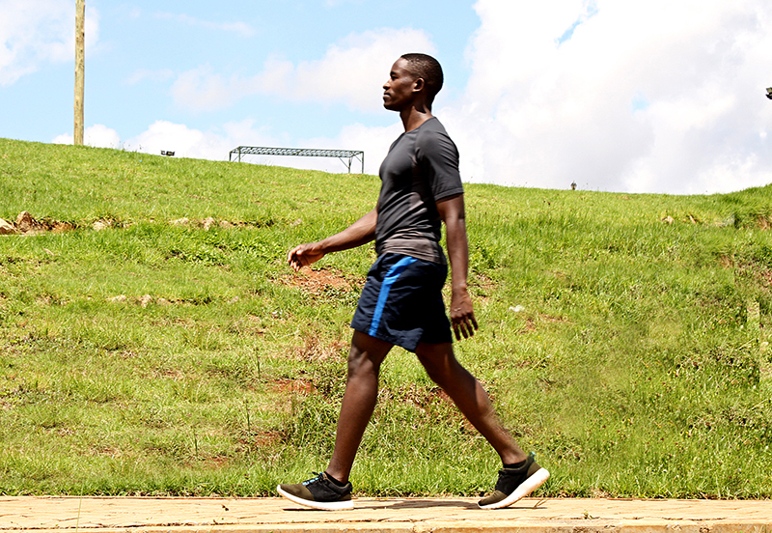
APPENDIX – COVID-19
Social Distancing Guidelines and Safety Information
Most shelter-in-place mandates allow for people to go outside and engage in solo outdoor activity, including walking. Follow the directions of your local health authority or learn how to protect yourself at www.cdc.gov/covid19.

Practice Social Distancing

Social distancing, also called “physical distancing,” means keeping space between yourself and other people outside of your home. To practice social or physical distancing:
- Stay at least 6 feet (about 2 arms’ length) from other people.
- Do not gather in groups.
- Stay out of crowded places and avoid mass gatherings.
Other Precautions:
Wash your hands before you leave and as soon as you get home.
Participants should NOT exercise if they have a fever, cough and/or difficulty breathing.
General Safety Information
If you share a home, tell others when you leave and when you expect to be home.
If you own a mobile phone, bring it with you.
Avoid busy streets.
Avoid street and walkways with uneven ground and trip hazards.
If you’re walking in the early morning or late evening, wear bright and reflective clothing.
If you benefit from a mobility device – cane, walker, rollator or trekking pol, use it on your fitness walks.

