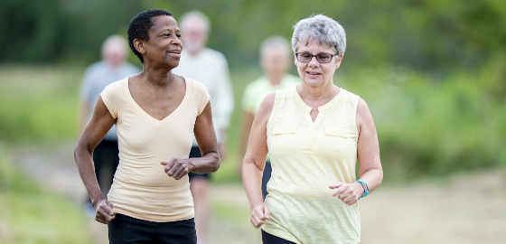

The Issue: At least 1 in 6 North Carolinians have Arthritis. More than half of all adults with Diabetes or Heart Disease also have Arthritis. Arthritis limits physical activity and complicates management of these other chronic diseases.

The Solution: Walking! The Arthritis Foundation’s Walk With Ease Program reduces the pain of arthritis and improves overall health--showing people how to safely make physical activity part of their everyday life.

The Program: Walk With Ease is a six-week program delivered in two formats: instructor-led group or self-directed individual. Both formats utilize a step-by-step workbook that includes:
- Motivational tools
- Strategies to set and monitor realistic goals for improving fitness
- Tips for Arthritis symptom management
- Appropriate stretching and strengthening exercises to protect joints and minimize pain

The Outcomes: Walk With Ease is a CDC-recommended Arthritis-appropriate evidence-based intervention that is proven to:
- Build confidence in the ability to be physically active
- Improve overall health
- Reduce the pain and discomfort of Arthritis
- Increase balance, strength and walking pace

There are over 150 trained Walk With Ease leaders across North Carolina.

(Data about # of programs or degree of minutes walked or confidence in chronic disease management)

The Walk With Ease self-directed state portal

Testimonials/quotes/stores and photos

Q: Have you continued to use what you learned in this program?
I still use the stretches, and I walk all I can every day. My goal is to be in better shape at 75 than I was at 65.
Q: How did the program help your understanding of chronic conditions?
It confirmed what I already knew. I already had an understanding of my conditions and knew you have to move. Moving is key, it really helps the pain. When you move, it keeps your joints open and expels chemical build-up. When you are walking you move all of your joints and keep everything free.
When I started the program I could hardly walk one lap around the arena even using walking sticks. By the end, I was among the faster ones and I could walk extra laps.
Q: What is one thing you would like others to know about this program if they are considering participating?
It was enjoyable. It’s good to get together and have people to talk to. I would’ve ended up in a wheelchair if I didn’t keep moving and being active, the program helped me to keep active.

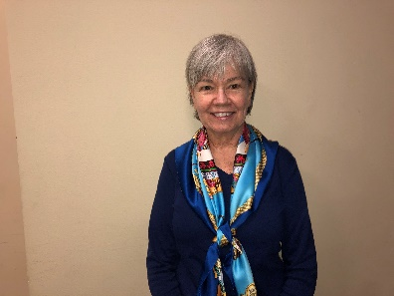
Q: What was the most helpful part of the Walk With Ease program?
The gentleness. There was no pressure. Structure was great too, having the book to read and walking 10 minutes at a time and not all at once. The FITT tool (frequency, intensity, time, type) was helpful to let me know I was doing too much and I learned to only increase one aspect at a time.

Q: Will you continue to use what you learned in this program?
Absolutely. I will still do the stretches. Before taking this class I was in pain all the time. I would overdo it and then be in pain and unable to get up for days. Now I do 10 minutes at a time and I feel so much better. I would like to teach this program in the future because I want people to know it helps. Just follow the program. Do what you can, even if it is only for a minute.

REFERENCES:
(NC Burden of Osteoarthritis, 2018) https://www.dropbox.com/sh/gx33njw3no5tmac/AABgmtwxwjoxN3j7-5NKx4PLa?dl=0&preview=NC+Burden+of+OA+2018.pdf

(Walk With Ease Issue Brief) https://oaaction.unc.edu/files/2018/08/Walk-With-Ease-issue-brief-REFERRER-final-3.pdf

(Walk With Ease stories) http://healthyagingnc.com/healthy-aging-stories/

